**Java Web开发**

**实验六**

**作业报告**

|  |  |
| --- | --- |
| 学 院 | 计算机 |
| 所在系 班 级 | 2017软件工程系8班 |
| 学 号 姓 名 | 马佳敏 |
| 指 导 教 师 | 郭晓燕 |
| 完 成 时 间 | 2018年4月5 |

# 实验题目

参考成熟的购物系统，为购物车增加功能，完善购物车：删除商品，查看商品具体信息，计算商品总价，修改商品购买件数等等。界面尽量美观。

提示：Java文件即Book.java的设计需要重构，需要分离商品基本信息和购买信息，需要有类分别来保存单件商品的购买信息和所有商品的购买信息。所以至少要三个Java类才能完成购物的基本功能。

Servlet也需要响应更多的操作，可以在一个Servlet中也可以分多个文件响应。并在适当的地方调用Java方法。

# 分析与设计

建立bookbuy.jsp文件初始化图书对象数组并将其放入session中，初始化购书总数sum放入session中，遍历图书数组，获取图书图片和id，将其循环显示在页面上，以便查看、选购和链接传参。

建立一个servlet caigou.java文件，用于建立session对象，获取并判断每本书下的超链接id，符合的id对应的书本数量加一存入图书数组中，caimai.java文件用于进行商品数量的增添和减少 而carbook.jsp用于获取sum和数组中每本书对应的数量，将其遍历循环输出，并计数总价，book.java文件用于图书数组的定义和方法实现，aboutbook.jsp用于显示书本的详细信息

# 关键源码（部分）

**Book.java**

**package** Book;

**public** **class** Book **implements** java.io.Serializable{

String bookID;

String bookName;

String bookurl;

String bookinstro;

**int** bookprice;

**int** booknumber;

**public** Book(String id,String name,String url,**int** price,**int** number,String instroduce)

{

**this**.bookID=id;

**this**.bookName=name;

**this**.bookurl=url;

**this**.bookprice=price;

**this**.bookinstro=instroduce;

**this**.booknumber=number;

}

**public** String getbookID() {

**return** bookID;

}

**public** **void** setProductID(String bookID) {

**this**.bookID=bookID;

}

**public** String getbookName() {

**return** bookName;

}

**public** **void** setbookName(String bookName) {

**this**.bookName=bookName;

}

**public** String getbookurl() {

**return** bookurl;

}

**public** **void** setbookurl(String bookurl) {

**this**.bookurl=bookurl;

}

**public** **int** getbookprice() {

**return** bookprice;

}

**public** **void** setbookprice(**int** bookprice) {

**this**.bookprice=bookprice;

}

**public** String getbookinstro() {

**return** bookinstro;

}

**public** **void** setbookinstro(String bookinstro) {

**this**.bookinstro=bookinstro;

}

**public** **int** getbooknumber() {

**return** booknumber;

}

**public** **void** setbooknumber(**int** booknumber) {

**this**.booknumber=booknumber;

}

}

**bookbuy.jsp**

<%@ page language=*"java"* contentType=*"text/html; charset=UTF-8"*

pageEncoding=*"UTF-8"* import=*"Book.Book"*%>

<!DOCTYPE html PUBLIC "-//W3C//DTD HTML 4.01 Transitional//EN" "http://www.w3.org/TR/html4/loose.dtd">

<html>

<head>

<meta http-equiv=*"Content-Type"* content=*"text/html; charset=UTF-8"*>

<title>BuyBook</title>

</head>

<%**if**(session.getAttribute("sum")==**null**)

session.setAttribute("sum", 0);%>

<%

**if**(session.getAttribute("bookList")==**null**)

{

Book[] booklist=**new** Book[3];

booklist[0]=**new** Book("a","爱丽丝又不见了","timg 1.jpg",25,0,"《爱丽丝又不见了》这是爱丽丝的故事，她总是走到哪儿就掉到哪儿。害得她的爷爷、爸爸、妈妈到处找她。从这里，可以清清楚楚地感受到作家饱满的童心，是一个浸透着爱的故事。");

booklist[1]=**new** Book("b","金银岛","timg 2.jpg",35,0,"《金银岛》讲述的是18世纪中期英国少年吉姆从垂危水手彭斯手中得到传说中的藏宝图，在当地乡绅支援下组织探险队前往金银岛。并与冈恩众人智斗海盗，最终平息了叛变并成功取得宝藏的故事。");

booklist[2]=**new** Book("c","唐诗","timg 3.jpg",15,0,"专为幼儿精选的唐诗选集，有利于幼儿启蒙，从小培养中国文化");

session.setAttribute("bookList", booklist);

}

%>

<body>

<table>

<tr>

<th><h1><img src=*"timg.jpg"* width=*"200"* height=*"200"*></h1></th>

<th><h1><a href=*"carbook.jsp"*>已采购<%=session.getAttribute("sum") %>本书</a></h1></th>

<th></th>

</tr>

<%

Book[] booklist=(Book[])session.getAttribute("bookList");

**if**(booklist!=**null**)

{

out.print("<tr>");

**for** (Book b:booklist)

out.println("<td><img src='"+b.getbookurl()+"' width='300' height='300'></td>");

out.print("</tr>");

out.print("<tr>");

**for** (Book b:booklist)

out.println("<td align='center'><h1><a href='aboutbook.jsp?bookid="+b.getbookID()+"'>查看详情</a></h1></td>");

out.print("</tr>");

out.print("<tr>");

**for** (Book b:booklist)

out.println("<td align='center'><h1><a href='caigou?bookid="+b.getbookID()+"'>采购此书</a></h1></td>");

out.print("</tr>");

}

%>

</table>

</body>

</html>

**caigou.java**

**package** Book;

**import** java.io.IOException;

**import** javax.servlet.ServletException;

**import** javax.servlet.annotation.WebServlet;

**import** javax.servlet.http.HttpServlet;

**import** javax.servlet.http.HttpServletRequest;

**import** javax.servlet.http.HttpServletResponse;

**import** javax.servlet.http.HttpSession;

@WebServlet("/caigou")

**public** **class** caigou **extends** HttpServlet {

**protected** **void** doGet(HttpServletRequest request, HttpServletResponse response) **throws** ServletException, IOException {

request.setCharacterEncoding("UTF-8");

response.setContentType("text/html;charset=utf-8");

HttpSession session=request.getSession();

String bookid=request.getParameter("bookid");

**int** sum=(**int**)session.getAttribute("sum");

Book[] blist=(Book[])session.getAttribute("bookList");

**for**(**int** i=0;i<blist.length;i++)

{

**if**(bookid.equals(blist[i].getbookID()))

{

sum++;

blist[i].setbooknumber(blist[i].getbooknumber()+1);

**break**;

}

}

session.setAttribute("sum",sum);

request.getRequestDispatcher("bookbuy.jsp").forward(request,response);

}

}

**carbook.jsp**

<%@ page language=*"java"* contentType=*"text/html; charset=UTF-8"*

pageEncoding=*"UTF-8"* import=*"Book.Book"*%>

<!DOCTYPE html PUBLIC "-//W3C//DTD HTML 4.01 Transitional//EN" "http://www.w3.org/TR/html4/loose.dtd">

<html>

<head>

<meta http-equiv=*"Content-Type"* content=*"text/html; charset=UTF-8"*>

<title>Book's Car</title>

<style>

**table,th,td**

{

border:*1px solid black*;

border-collapse: *collapse*;

}

</style>

</head>

<%

Book[] booklist=(Book[])session.getAttribute("bookList");

**if**(session.getAttribute("all")==**null**)

session.setAttribute("all", 0);

**int** ss=0;

**for**(**int** i=0;i<booklist.length;i++)

{

ss=ss+booklist[i].getbookprice()*booklist[i].getbooknumber();

//session.setAttribute("all",(int)session.getAttribute("all")+booklist[i].getbookprice()*booklist[i].getbooknumber());

}

session.setAttribute("all",ss);

%>

<body>

<h1>已采购<%=session.getAttribute("sum") %>本书&nbsp&nbsp&nbsp&nbsp&nbsp&nbsp&nbsp&nbsp<a href=*"bookbuy.jsp"*>返回购书</a></h1>

<h1>总计<%=session.getAttribute("all") %>元</h1>

<table>

<%

**for** (Book b:booklist)

{

out.print("<tr>");

out.println("<td><img src='"+b.getbookurl()+"' width='300' height='300'></td>");

out.println("<td align='center' width='150'><h1>"+b.getbooknumber()*b.getbookprice()+"元</h1></td>");

out.println("<td align='center' width='250'><h1><a href='caimai?bookid="+b.getbookID()+"&name=add'><input type='submit' value='+'></a>共"+b.getbooknumber()+"本<a href='caimai?bookid="+b.getbookID()+"&name=delet'><input type='submit' value='-'></a></h1></td>");

out.print("</tr>");

}

%>

</table>

</body>

</html>

**Caimai.java**

package Book;

import java.io.IOException;

import javax.servlet.ServletException;

import javax.servlet.annotation.WebServlet;

import javax.servlet.http.HttpServlet;

import javax.servlet.http.HttpServletRequest;

import javax.servlet.http.HttpServletResponse;

import javax.servlet.http.HttpSession;

@WebServlet("/caimai")

public class caimai extends HttpServlet {

protected void doGet(HttpServletRequest request, HttpServletResponse response) throws ServletException, IOException {

request.setCharacterEncoding("UTF-8");

response.setContentType("text/html;charset=utf-8");

HttpSession session=request.getSession();

String submit=request.getParameter("name");

String bookid=request.getParameter("bookid");

int sum=(int)session.getAttribute("sum");

Book[] blist=(Book[])session.getAttribute("bookList");

if(submit.equals("add"))

{

for(int i=0;i<blist.length;i++)

{

if(bookid.equals(blist[i].getbookID()))

{

sum++;

blist[i].setbooknumber(blist[i].getbooknumber()+1);

// session.setAttribute("all", (int)session.getAttribute("all")+blist[i].getbookprice());

break;

}

}

}

if(submit.equals("delet"))

{

for(int i=0;i<blist.length;i++)

{

if(bookid.equals(blist[i].getbookID()))

{

sum--;

blist[i].setbooknumber(blist[i].getbooknumber()-1);

//session.setAttribute("all", (int)session.getAttribute("all")-blist[i].getbookprice());

break;

}

}

}

session.setAttribute("sum",sum);

request.getRequestDispatcher("carbook.jsp").forward(request,response);

}

}

**aboutbook.java**

<%@ page language=*"java"* contentType=*"text/html; charset=UTF-8"*

pageEncoding=*"UTF-8"* import=*"Book.Book"*%>

<!DOCTYPE html PUBLIC "-//W3C//DTD HTML 4.01 Transitional//EN" "http://www.w3.org/TR/html4/loose.dtd">

<html>

<head>

<meta http-equiv=*"Content-Type"* content=*"text/html; charset=UTF-8"*>

<title>Book's message</title>

</head>

<%

**int** k=0;

String bookid=request.getParameter("bookid");

Book[] booklist=(Book[])session.getAttribute("bookList");

**for**(**int** i=0;i<booklist.length;i++)

**if**(bookid.equals(booklist[i].getbookID()))

k=i;

%>

<body>

<table width=*"1000"*>

<tr>

<td rowspan=*"2"*><img src=*"*<%=booklist[k].getbookurl()%>*"* width=*"300"* height=*"300"*></td>

<td align=*"center"*><h1><%=booklist[k].getbookName() %></h1></td>

</tr>

<tr>

<td align=*"center"*><h1><%=booklist[k].getbookprice()%>元/本</h1></td>

</tr>

<tr>

<td colspan=*"2"*><h2><%=booklist[k].getbookinstro() %></h2></td>

</tr>

</table>

</body>

</html>

# 运行效果图

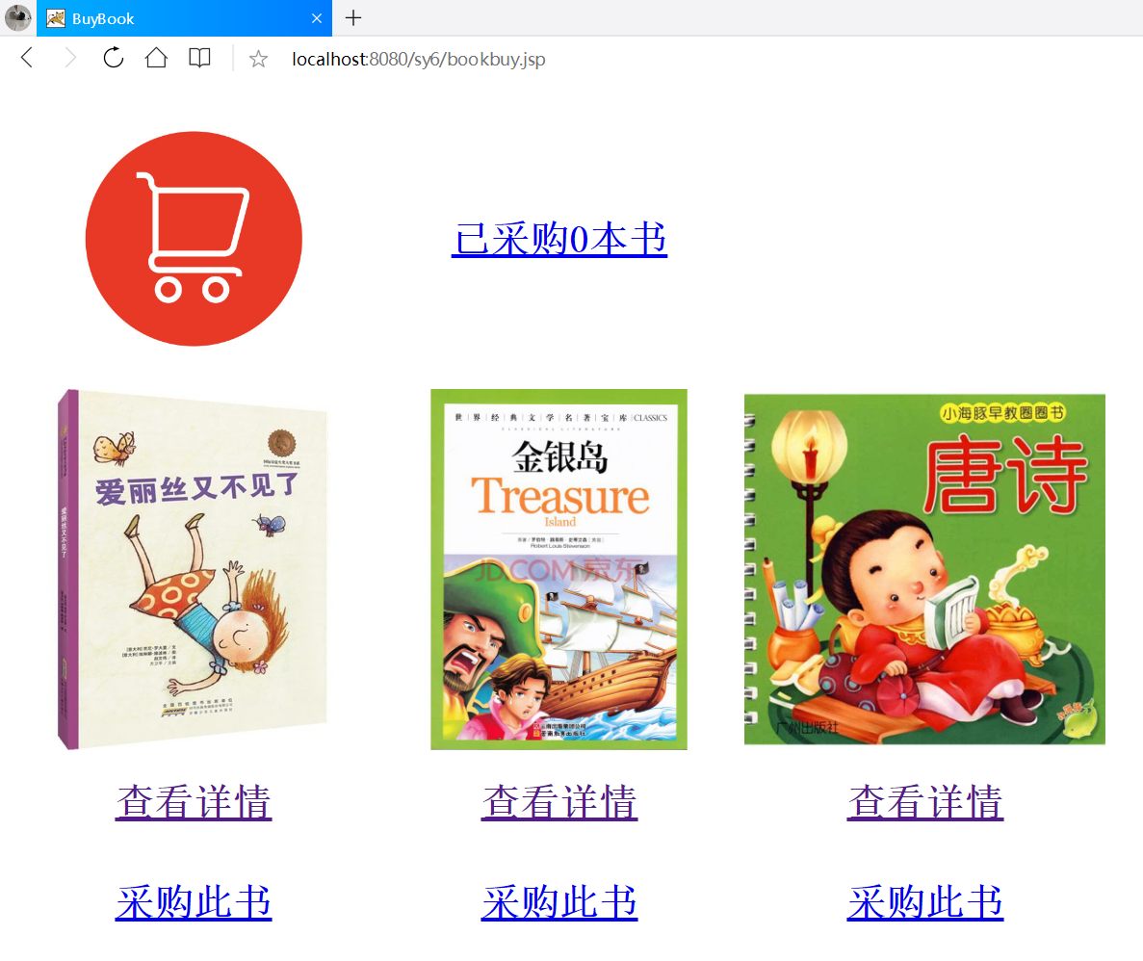

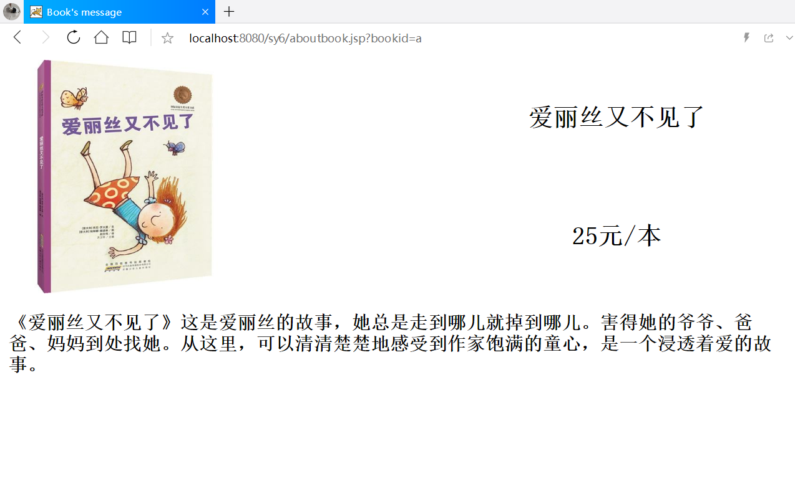

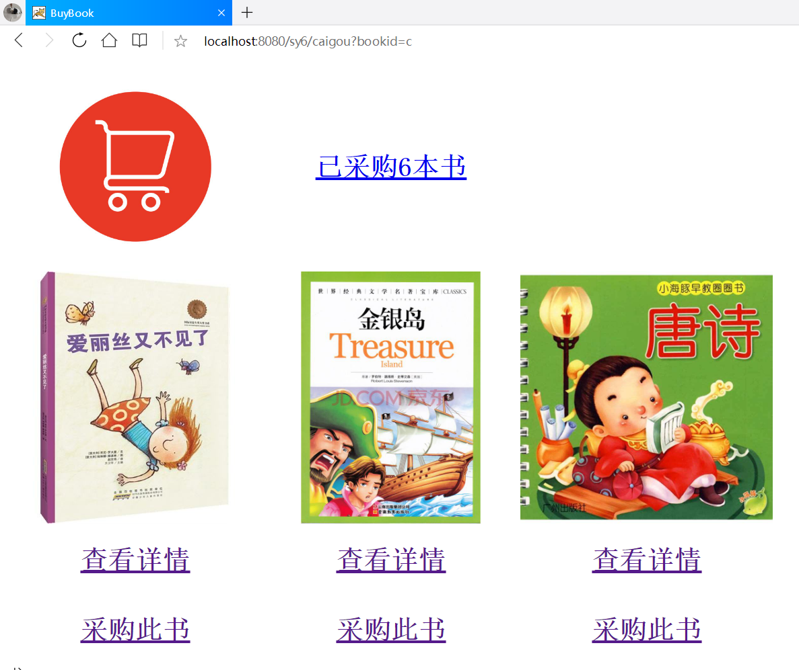 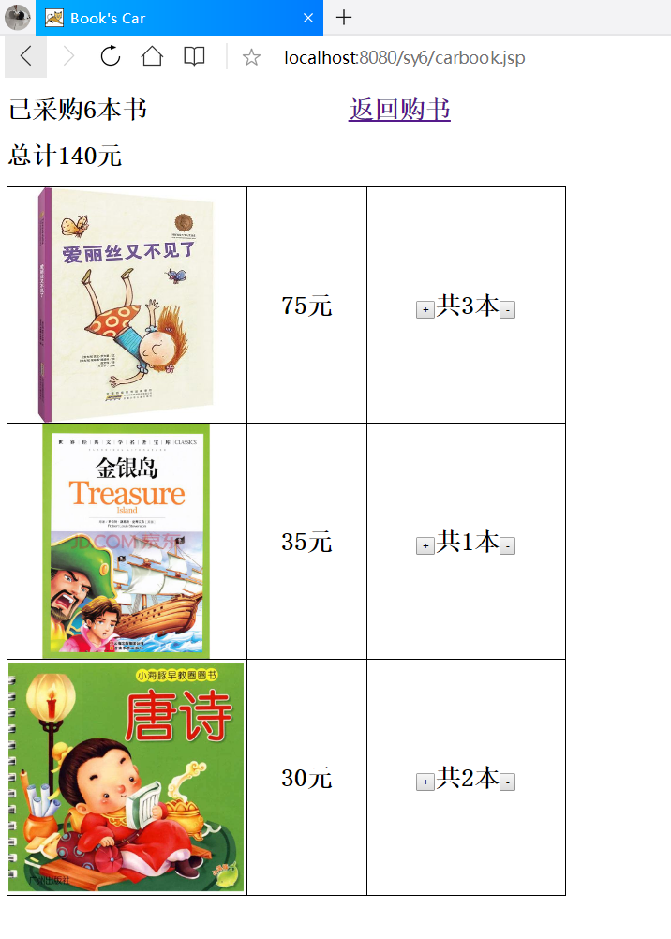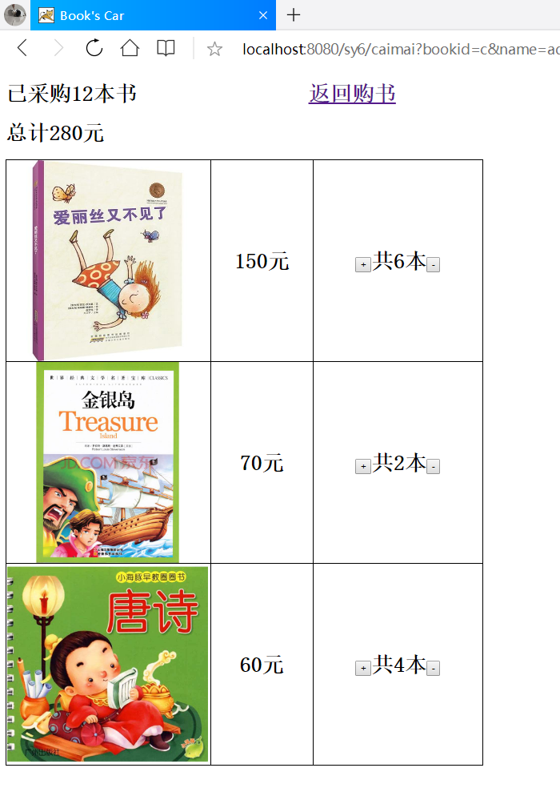

# 收获与问题

把对象数组放入session并循环调用输出增加代码可改性